1. POLICY STATEMENT
genU (being Karingal St Laurence Limited and its subsidiaries) is committed to a culture of the highest ethical standards and behaviours, including promoting honesty, fairness, and openness in its relations with stakeholders such as employees, clients, contractors, and regulators.
Consistent with that commitment, the purpose of this policy is to encourage the reporting of matters which are protected disclosures under respective whistleblower laws, through appropriate channels and without fear of intimidation, disadvantage, or reprisal.

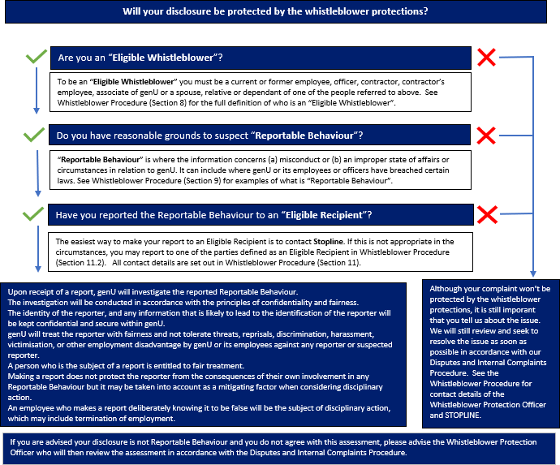
2. DETERMINING ELIGIBLE WHISTLEBLOWER DISCLOSURES

The reporting of Reportable Behaviours is an important mechanism to assist genU to monitor and manage its risks generally as well as its ethical standards and behaviours, and compliance with its systems, policies, and the law.
Detailed information regarding the protection eligibility criteria and reporting process is contained in the Whistleblower Procedure.
This policy is accessible through a number of pathways including:
- genU intranet;
- genU website (genu.org.au);
- genU induction training undertaken by all employees of genU;
- by requesting a copy from the Whistleblower Protection Officer (See Whistleblower Procedure Section 12.2).

3. REVIEW AND AMENDMENT OF POLICY
genU will review this Whistleblower Policy regularly for its effectiveness, following any legislative amendments or every 3 years whichever occurs sooner. Any amendments must be approved by the genU Board of Directors.

4. RELATED DOCUMENTS
- Whistleblower Procedure
- genU Code of Conduct
- Disputes and Internal Complaints Procedure
- genU Risk Appetite Statements

5. LEGISLATION & RELATED REFERENCES
The Whistleblower Policy and Whistleblower Procedure comply with relevant legislation. Legislation which relates to whistleblower disclosures includes:
- Australian Securities Investment Commission Act 2001 (Cth) (ASIC Act)
- Corporations Act 2001 (Cth) (Corporations Act)
- Fair Work Act 2009 (Cth)
- Public Interest Disclosures Act 2012 (Vic)
- Public Interest Disclosure Act 2013 (Cth)
- Taxation Administration Act 1953 (Cth)

6. RELATED RECORDS
Records must be maintained as per legal and contractual requirements. For guidance please refer to the Records and Information Management Policy and the Records Retention and Disposal Schedule.

